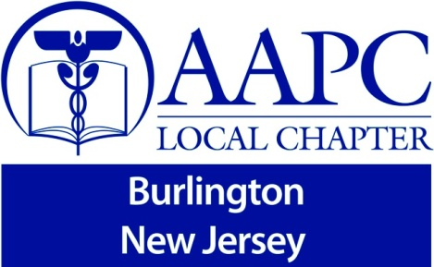

“Physician Billing for Inpatient Services”

Saturday, December 6, 2014
Presented by Jo Bowen, CPC, CCP
Owner of “Billing Management Services, Inc.”
Resources Needed: CPT & HCPCS Manuals

***Seating is limited*** ***Seating is limited***

Time Topic
9:00am – 9:25am Registration

9:30am – 10:15am Nursing Facility Physician Billing

10:15am – 12:00pm Inpatient Hospital Physician Billing

12:00pm to 12:30pm Break – Lunch will be provided

12:30pm – 12:45pm Critical Care Physician Billing

12:45pm – 1:00pm Assisted Living Physician Billing

1:00pm – 2:00pm Observation Care Physician Billing

2:00pm to 2:30pm Outpatient Hospital Physician Billing

2:30pm to 3:00pm Inpatient Consultation

3:00pm to 3:30pm Insurance Recognition for NJ/PA & BCBS’s

3:30pm to 4:00pm Question and Answer

Total Time: 6 Hours
CEU’s: 6 approved
Cost is $35.00 for AAPC members and $75.00 for Non-AAPC members. Registration deadline and payment is due by November 12, 2014. Pay pal will be emailed to you, registration will be complete upon payment. No personal Checks will be accepted. You must have your AAPC ID# or you will have to pay the Non-AAPC member rate. This seminar fills quickly and has limited seating capacity. No refunds for no shows or cancellations.
To register, please send an email to: Jo Bowen, CPC, CCP, jobowen@comcast.net.
Or call 609-261-5755
Merit Training Institute is conveniently located in Burlington Twp., New Jersey, inside the Burlington Center Mall. The location is less than a mile from exit 47a on I-295 and exit 5 off of the NJ Turnpike. It is located on the lower level of the mall, down the old Macy’s wing where the gym is located. If lost call 609-744-2486.

Address for GPS: 2501 Mt Holly Rd Burlington, New Jersey 08016
(We are in the Burlington Center Mall – lower level)

